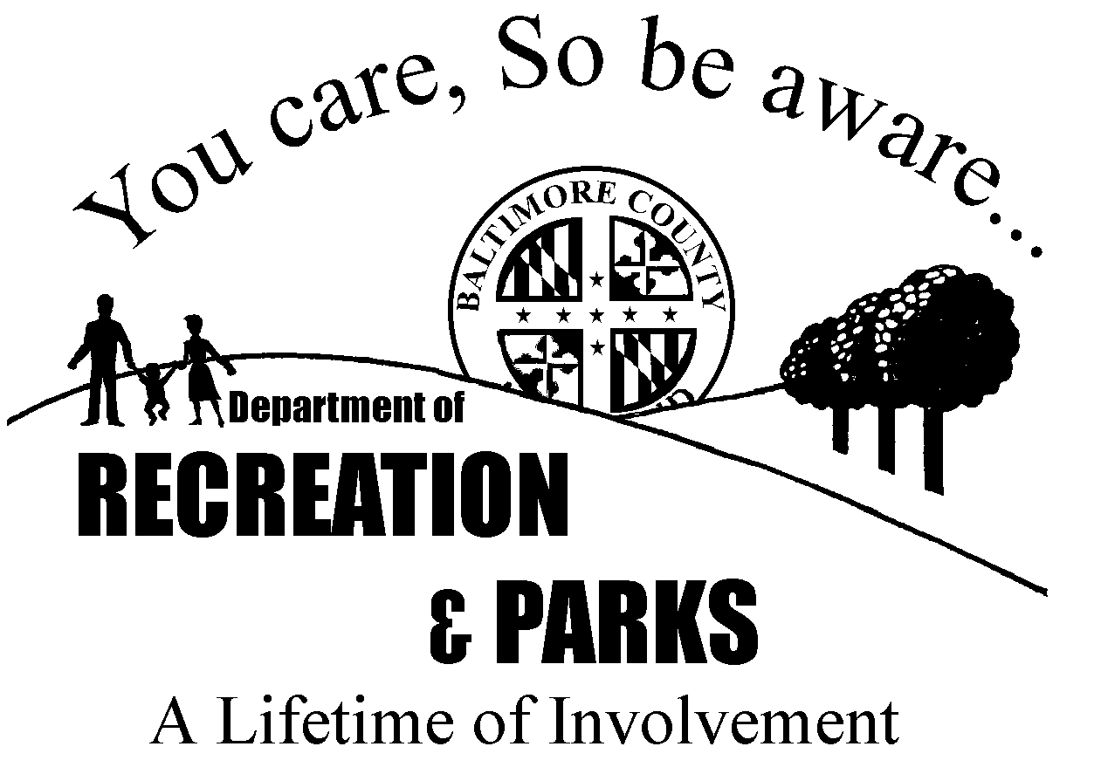

PARENTS CODE OF CONDUCT

- As a parent, I acknowledge the importance of being involved in my child’s recreational activities.

- I will introduce myself to my child’s volunteer coaches/leaders and will exchange pertinent contact information with them.

- I will know who is transporting my child to and from any recreational activity.

- I will know my child’s schedule – practice days, dates and schedules.

- I will help ensure a drug, alcohol and tobacco-free environment for my child.

- I will place the emotional and physical well-being of my child ahead of any personal desire to succeed.

- I will provide support for coaches and leaders working with my child to provide a positive, enjoyable experience for all.

- My child and I will treat other participants, spectators and officials with respect regardless of race, sex, creed or ability.

- I am aware of the fact that the Baltimore County Department of Recreation and Parks does not provide background checks on volunteers because experts, including the Baltimore County Police Dept. agree that parental involvement is a more effective means of protecting children.

Signature_________________________________________ Date__________________

